Multi File Demo

Video: <https://youtu.be/MuRLa6_CL44>

1. Open Program4-02 AskNameAgeFunc by clicking on the .sln file:

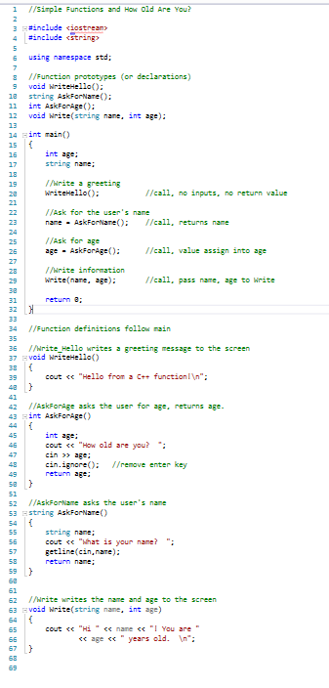

1. We are going to convert this single file program in to a multi file program with:
   1. Driver.cpp
   2. Functions.h
   3. Funcitons.cpp

# Functions.h

1. Right click on the Header Files folder in your project and add a new item:

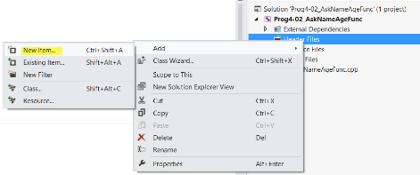

1. Add a new header file. Call it Functions.h:

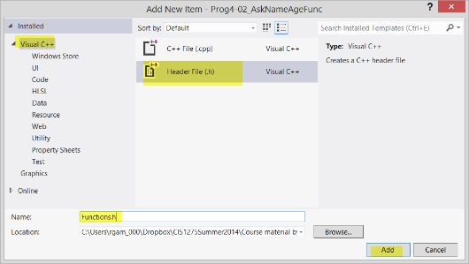

1. Cut the function prototypes from AskNameAgeFunc.cpp:

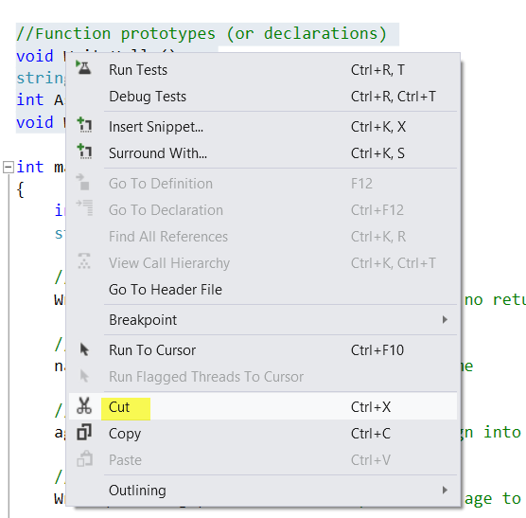

1. Paste them into Functions.h:

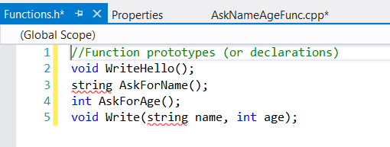

1. Add #include <string> and using namespace std; to clear the errors.

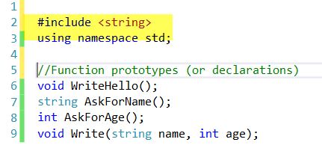

1. Add pre-processor directives and comment block:

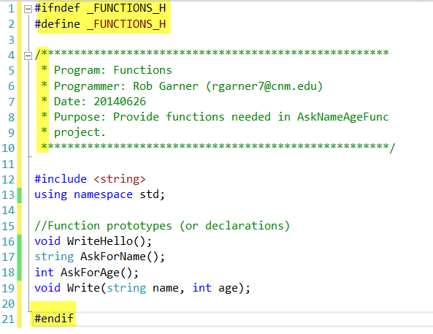

1. Congratulations you completed the header file!

# Functions.cpp

1. Now we will create the Functions.cpp file that will contain the bodies of our functions:
2. Add a Function.cpp file to your Source Files directory:

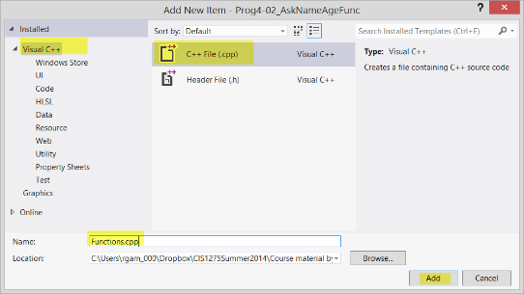

1. Cut the function bodies out of AskNameAgeFunc.cpp:

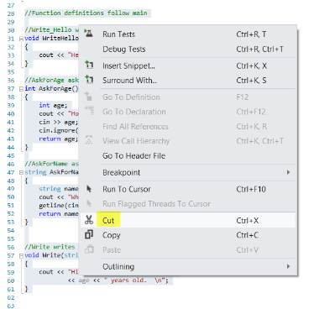

1. Paste them into Functions.cpp:

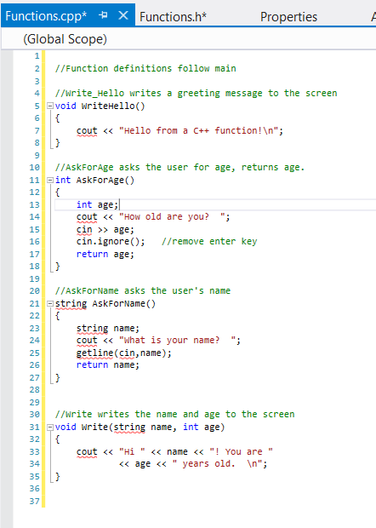

1. Add a comment header, includes and using statements. Note that we must include “Functions.h”!

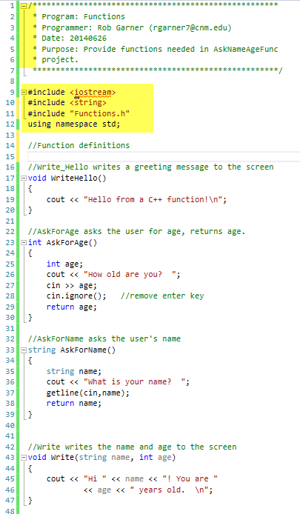

1. Congratulations you completed the Functions.cpp file!

# Driver.cpp

1. Rename AskNameAgeFunc to Driver.cpp:

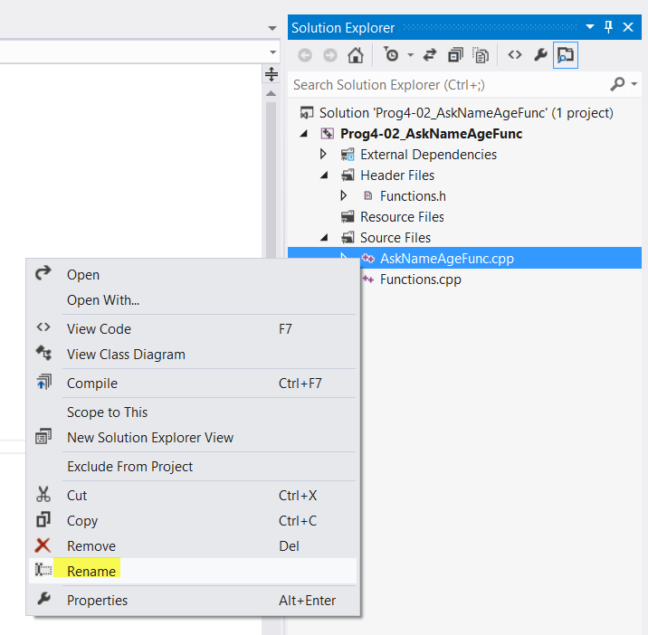

1. Note that we have a lot of errors in Driver.cpp for functions not defined!

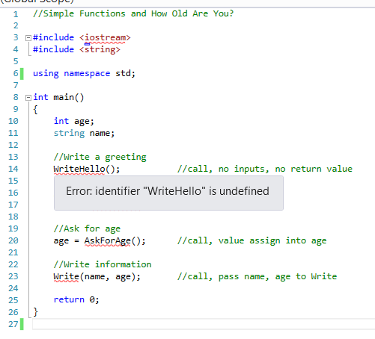

1. Fix it by including Functions.h:

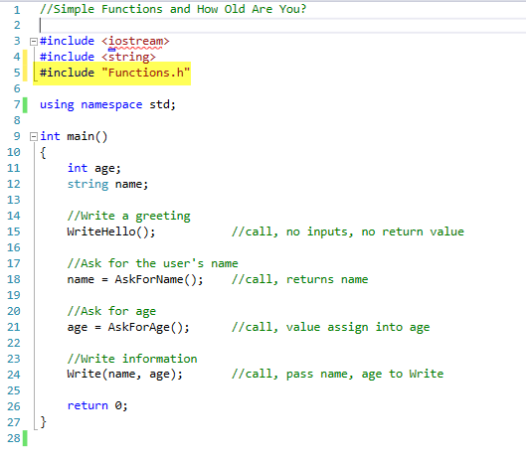

1. Add a comment header.

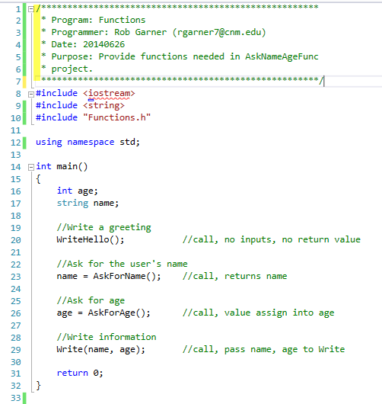

1. We are done! Test it with Ctrl-F5.

